**Project Name:** Data Visualization Software (Java)

**Github Link:** https://github.com/projectsforstudents2022/Data_Visualization_Software-Java.git

**Why was this project created?**

Statistics includes data visualization as one of its key themes. As effective descriptive tools throughout the history of statistics, statistical graphs for data visualization, such as histograms and scatter plots, have been used to grasp the features of data at every level of data analysis. Because Java is object-oriented, it is excellent for graphical programming, and well-designed standard graphical libraries reduce our programming tasks and make software more portable between platforms.

**What problem is it solving?**

To make data easier for the human brain to grasp and draw conclusions from, data visualization is the practice of putting information into a visual context, like a map or graph. Data visualization's major objective is to make it simpler to spot patterns, trends, and outliers in big data sets. Give complex sets of data and information the essential insights, and effectively communicate ideas.

**Entire explanation of project**

* **PROPOSED APPROACH**

We frequently need to combine fundamental graphs to create new statistical graphs. A scatter plot matrix, which consists of scatter plots arranged like a square matrix, is a nice example. Frequently, a histogram and a density estimation graph are superimposed. By utilizing its essential components, the statistical graphics library should assist these compositions in operating effectively. We frequently want to concentrate on and emphasize some observations so that we may see their features while ignoring other observations. We may employ the brushing technique to concentrate a collection of observations that are situated close together. If we link numerous statistical graphs at once, interactive processes are extremely effective. Drawing multiple graphs for a single dataset to identify its properties is a common practice. It is well acknowledged that object-oriented programming is an effective paradigm for obtaining strong software extension and reusability. The Java Application Programming Interface provides documentation for Java libraries (API). Java packages, classes, and interfaces are listed in the API along with all of their methods, properties, and constructors as well as usage instructions. Classes and objects can be merged to create larger structures, according to structural patterns. Inheritance can be used to create software interfaces that are more usable, according to patterns for classes.

* **RESULT**

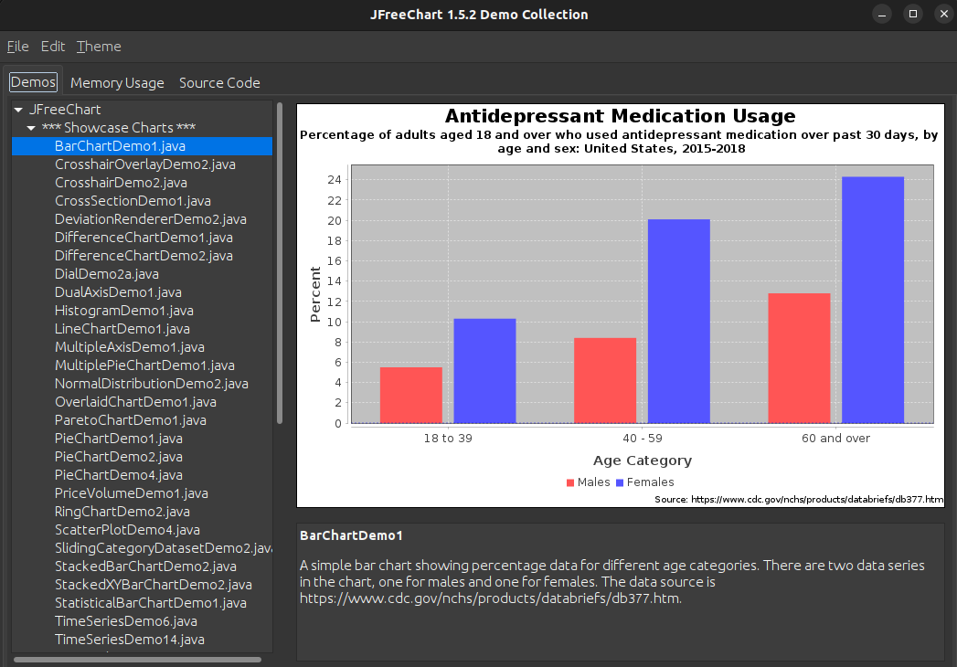

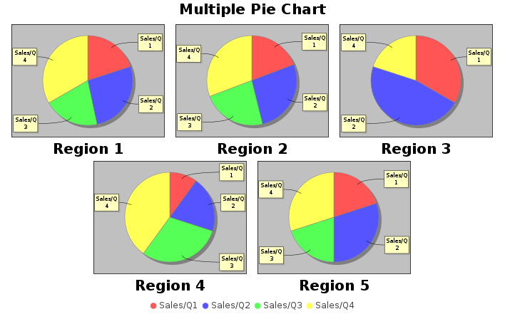

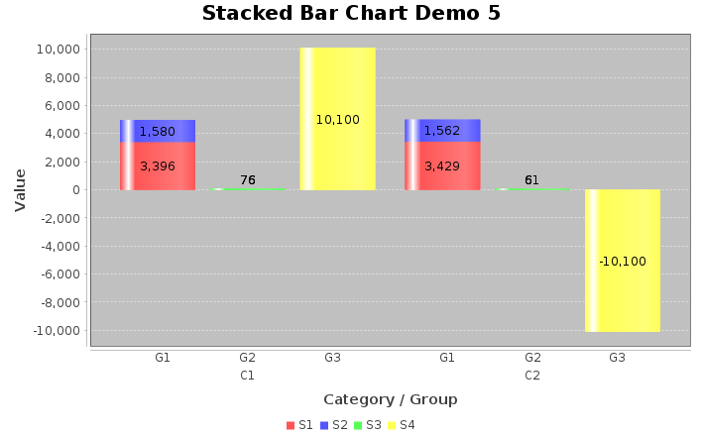

* **CONCLUSION**

Data visualization is used to communicate and interpret information more simply in a variety of contexts, including software, biotechnology, education, and research. In addition to successfully conveying information, it tends to draw viewers' interest and participation. To improve and expand the capabilities of this software, new features and improvements may be added as needed.